IES Consulting – Your internship abroad!
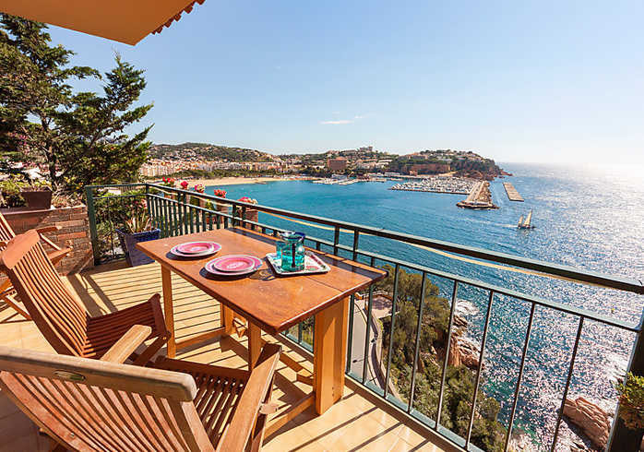
Bartender in Costa Brava
WHERE? Girona, Costa Brava, Spain
WHEN? Position available from June/July
DURATION: minimum 3 months
HOW MANY HOURS? Full-time, 40h/week
Before you start recruitment process, please check with your school if they would accept UNIVERSITY AGREEMENT which needs to be signed at the end of recruitment process.

Located in the beautiful Costa Brava with direct access to the beach, this Camping is recognized for the quality of its facilities, their big gardens and excellent customer service. They offer a lot of activities for the whole family: sports, cultural, excursions, etc. Their nightly shows are beautiful and striking. In addition to the Bungalows and Villas they have a 4 * Hotel. This Camping is the perfect opportunity to make your internships in an international environment with colleagues around the world.
The tasks:
Participation in the organisation of the bar:
- Taking orders;
- Making drinks and cocktails;
- Service inside and outside the restaurant;
- Service in the pool area.

We are looking for:
- Studies: Philology, Administration, Tourism etc.
- Languages: INTERMEDIATE ENGLISH + BASIC SPANISH

We offer:
- Remuneration: 300€/month + meals + accommodation
- Interesting tasks, international and pleasant work environment
APPLY NOW! Please send us your CV in English or Spanish to
interns@ies-consulting.es with the title BartenderCostaBrava

* Our recruitment process is free. Only if you get accepted and the company confirms your application, we will require an administration fee. All our internships provide salary, so we guarantee that costs of the service will pay off.

