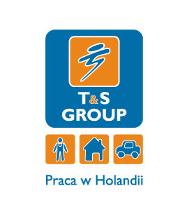

reachtruch/heftruck
wanted as soon as possible!
T&S Group is an employment agency with multiple years of experience (the group possesses the KRAZ 3745 certificate).
Job description:
- Reachtruck/Heftruck operator in an electronic equipment warehouse,
- work with a scanner, transport of shipments/orders with the fork-lift in between the departments
- collecting orders and other warehouse works
- possible work at packaging of electronic equipment, scanning of products, wrapping pallets in film, preparation for shipment
Requirements:
- Reachtruck or heftruck operator certificate (please include scans of certificates during registration),
- experience as a Reachtruck / heftruck operator (min. 2 years),
- good proficiency in the English language,
- lack of entries in the National Criminal Register (certificate of no criminal record),
- B category driving license is welcome,
We offer:
- work in a prestigious company with the opportunity of occupational development
- opportunity of long-term cooperation
- good remuneration with possible raise
- work in a nice and friendly environment
- possibility of using the accommodation, insurance and local transport offered by the employment agency in the Netherlands or organisation of these provisions by the employee himself or herself
- guardianship of Polish residents.
Additional information:
The first applications to be reviewed during the recruitment process are the ones sent via the form at thewww.tnsgroup.pl and fulfilling the required criteria. The CV must include the scan of a fork-lift operator certificate and the certificate of no criminal record.

